Chapter 3 p.79

Device vulnerabilities in industrial control networks

Bar graph showing the percentage of device vulnerability. It shows 46% of total devices with CVEs that cannot be patched due to firmware no longer being supported and 32% of total vulnerable devices with CVEs that customers could potentially patch.

Bar graph showing the percentage of devices classified as non-vulnerable. It shows that 15% of total devices have no CVEs, and 7% of total devices have been patched by customers to address vulnerabilities.

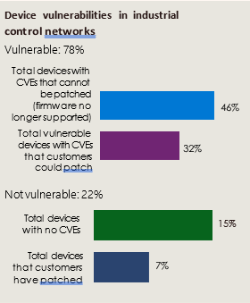

Source: Microsoft Defender for IoT sensors